Nevada Connections Academy (Distance Education), K-12 – State Public Charter – Reno/Sparks - Opened 2007
** Data can also be found under in the Nevada Report Card: NCA, NCA ES, NCA HS**

Nevada Connections Academy
555 Double Eagle Ct.
Suite 2000
Reno, NV 89521
775-826-4200

http://www.connectionsacademy.com/nevada-virtual-school

Nevada Connections Academy (Distance Education)
School Year Begun Operation: 2007-2008 (FY2008)
Sponsor: State Public Charter School Authority
Grades: K-12
Principal: Steven Werlein, swerlein@connectionseducation.com
Mailing Address: 175 Salomon Circle, Sparks 89434
Physical Address: Same as mailing address
Phone: 775.826.4200 x301
FAX: 775.826.4288
Website: www.connectionsacademy.com/nevada-school/home.aspx (Nevada link)

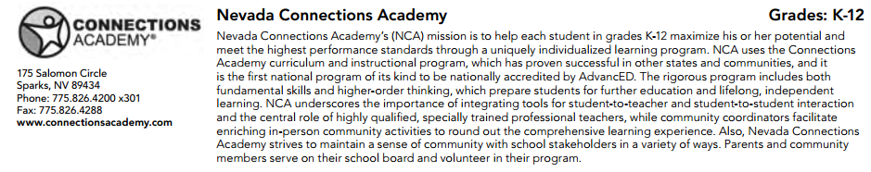
http://www.nevadacharters.org/wp-content/uploads/2013/07/2013_csan_guide.pdf

Demographic Information

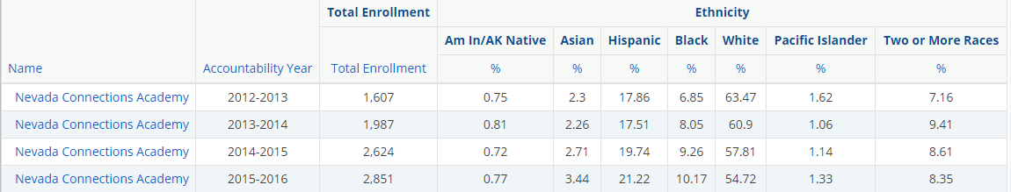

http://nevadareportcard.com/di/report/reportcard_1?report=reportcard_1&scope=e7.y1.y10.y11.y12.y13.y2.y3.y4.y5.y6.y7.y8.y9&organization=c12305&fields=309%2C310%2C311%2C313%2C318%2C320&hiddenfieldsid=309%2C310%2C311%2C313%2C318%2C320&scores=1026%2C573%2C574%2C575%2C805%2C576%2C577%2C806&num=160&page=5&pagesize=20&domain=demoprof&

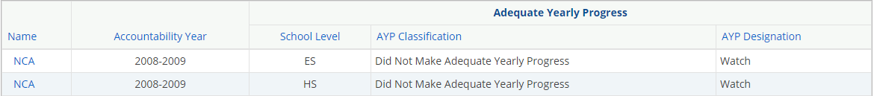
http://nevadareportcard.com/di/report/reportcard_1?report=reportcard_1&scope=e13.y4&organization=c3356&fields=309%2C310%2C311%2C313%2C318%2C320&hiddenfieldsid=309%2C310%2C311%2C313%2C318%2C320&scores=852%2C853%2C854&num=160&page=1&pagesize=20&domain=ayp&

Not Proficient Proficient
Test Scores – State Charter
 |  |  |  |  |  |  | Math |  |  |  |  |  |  |  | Reading
Year | Grade | Number  Enrolled | Number  Tested | Mean Scale  Score | % Proficient | % Above  Target | ED | AS | MS | ES | Number  Tested | Mean Scale  Score | % Proficient | % Above  Target | ED | AS | MS | ES
2008-2009  CRT (New NV Standards) Grade 3 | 3 | 20
2008-2009  CRT (New NV Standards) Grade 5 | 5 | 57 | 57 | 301.6 | 49.1 | -7.2 | 5.3 | 45.6 | 36.8 | 12.3 | 57 | 298.8 | 50.9 | -0.8 | 7.0 | 42.1 | 43.9 | 7.0
2008-2009  CRT (New NV Standards) Grade 8 | 8 | 105 | 95 | 302.2 | 47.4 | -7.3 | 9.5 | 43.2 | 42.1 | 5.3 | 95 | 321.9 | 73.7 | 15.7 | 2.1 | 24.2 | 68.4 | 5.3
2009 - 2010  CRT (New NV Standards) Grade 3 | 3 | 40 | 38 | 292.9 | 44.7 | -21.2 | 31.6 | 23.7 | 28.9 | 15.8 | 38 | 319.1 | 63.2 | -0.6 | 2.6 | 34.2 | 34.2 | 28.9
2009 - 2010  CRT (New NV Standards) Grade 5 | 5 | 66 | 65 | 309.7 | 56.9 | -9.0 | 24.6 | 18.5 | 55.4 | 1.5 | 65 | 327.6 | 70.8 | 7.0 | 0.0 | 29.2 | 58.5 | 12.3
2009 - 2010  CRT (New NV Standards) Grade 8 | 8 | 156 | 156 | 265.3 | 44.2 | -21.7 | 6.4 | 49.4 | 42.3 | 1.9 | 156 | 300.3 | 54.5 | -9.3 | 21.2 | 24.4 | 33.3 | 21.2
2010 - 2011  CRT (New NV Standards) Grade 3 | 3 | 61 | 60 | 295.1 | 45.0 | -20.9 | 21.7 | 33.3 | 25.0 | 20.0 | 61 | 299.2 | 54.1 | -9.7 | 31.1 | 13.1 | 31.1 | 23.0
2010 - 2011  CRT (New NV Standards) Grade 5 | 5 | 84 | 84 | 301.2 | 53.6 | -12.3 | 22.6 | 23.8 | 52.4 | 1.2 | 84 | 338.2 | 72.6 | 8.8 | 7.1 | 20.2 | 41.7 | 31.0
2010 - 2011  CRT (New NV Standards) Grade 8 | 8 | 168 | 167 | 252.6 | 37.7 | -32.3 | 16.8 | 45.5 | 34.7 | 3.0 | 167 | 301.5 | 52.7 | -3.7 | 18.0 | 29.3 | 25.1 | 27.5
2011-2012  CRT (New NV Standards) Grade 3 | 3 | 42 | 42 | 311.3 | 61.9 | -11.7 | 21.4 | 16.7 | 31.0 | 31.0 | 42 | 319.5 | 64.3 | -1.5 | 21.4 | 14.3 | 26.2 | 38.1
2011-2012  CRT (New NV Standards) Grade 5 | 5 | 85 | 85 | 306.6 | 54.1 | -19.4 | 24.7 | 21.2 | 50.6 | 3.5 | 85 | 335.8 | 70.6 | 4.8 | 10.6 | 18.8 | 49.4 | 21.2
2011-2012  CRT (New NV Standards) Grade 8 | 8 | 212 | 205 | 265.7 | 24.9 | -24.1 | 37.1 | 38.0 | 22.4 | 2.4 | 206 | 301.5 | 57.3 | -2.6 | 20.9 | 21.8 | 34.5 | 22.8
2012 - 2013  CRT (New NV Standards) Grade 3 | 3 | 52 | 52 | 303.2 | 55.8 | -15.8 | 17.3 | 26.9 | 32.7 | 23.1 | 52 | 321.5 | 65.4 | -2.0 | 17.3 | 17.3 | 40.4 | 25.0
2012 - 2013  CRT (New NV Standards) Grade 5 | 5 | 78 | 78 | 301.2 | 52.6 | .19.0 | 34.6 | 12.8 | 50.0 | 2.6 | 78 | 324.3 | 71.8 | 4.4 | 15.4 | 12.8 | 47.4 | 24.4
2012 - 2013  CRT (New NV Standards) Grade 8 | 8 | 220 | 220 | 262.4 | 24.1 | -24.1 | 36.8 | 39.1 | 24.1 | 0.0 | 220 | 300.2 | 57.3 | -2.9 | 22.3 | 20.5 | 30.9 | 26.4
2013-2014  CRT (New NV Standards) Grade 3 | 3 | 67 | 67 | 299.6 | 58.2 | -10.3 | 25.4 | 16.4 | 31.3 | 26.9 | 67 | 299.2 | 58.2 | -9.3 | 25.4 | 16.4 | 35.8 | 22.4
2013-2014  CRT (New NV Standards) Grade 5 | 5 | 73 |  |  |  |  |  |  |  |  | 72 | 334.9 | 73.6 | 6.1 | 12.5 | 13.9 | 47.2 | 26.4
2014-2015  CRT (New NV Standards) Grade 5 | 3
2014-2015  CRT (New NV Standards) Grade 5 | 5
2014-2015  CRT (New NV Standards) Grade 8 | 8
2015 – 2016  CRT (New NV Standards) Grade 3 | 03 | 184 | 158 | 2412.7 | 37.3 | TBD | 28.5 | 34.2 | 25.9 | 11.4 | 159 | 2434.1 | 57.9 | TBD | 19.5 | 22.6 | 31.4 | 26.4
2015 – 2016  CRT (New NV Standards) Grade 4 | 04 | 176 | 154 | 2445.7 | 33.8 | TBD | 33.8 | 32.5 | 26.6 | 7.1 | 155 | 2462.2 | 47.7 | TBD | 31.0 | 21.3 | 24.5 | 23.2
2015 – 2016  CRT (New NV Standards) Grade 5 | 05 | 215 | 184 | 2469.5 | 27.7 | TBD | 42.4 | 29.9 | 19.6 | 8.2 | 186 | 2506.3 | 54.8 | TBD | 22.6 | 22.6 | 38.2 | 16.7
2015 – 2016  CRT (New NV Standards) Grade 5 | 08 | 386 | 285 | 2493.7 | 14.7 | TBD | 58.6 | 26.7 | 10.2 | 4.6 | 316 | 2562.8 | 55.7 | TBD | 2.18 | 22.5 | 41.1 | 14.6

CRT (Old NV Standards), Grade 3
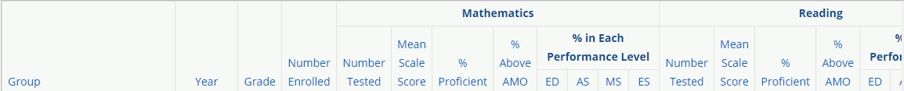
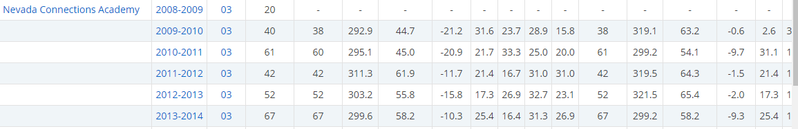
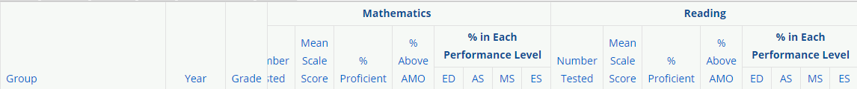
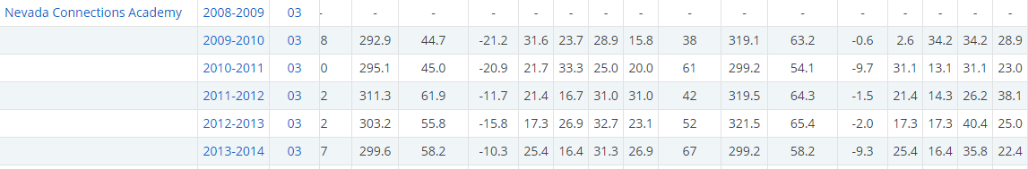
http://nevadareportcard.com/di/report/summary_1?report=summary_1&scope=e1.g3.y10.y11.y12.y3.y4.y5.y6.y7&organization=c12305&scores=MA_AMO%2CRD_AMO%2CMA_level%2CRD_level%2CMA_pass%2CRD_pass%2CMA_SS%2CRD_SS%2CN_MA%2CN_RD&num=20&page=1&pagesize=20&domain=assessment&
CRT (Old NV Standards), Year 2014-2015, Grade 5 (science)
CRT (Old NV Standards), Grade 5
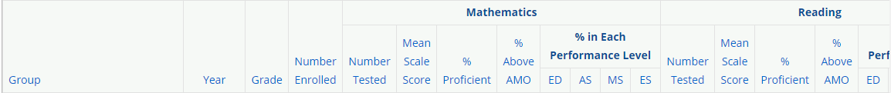
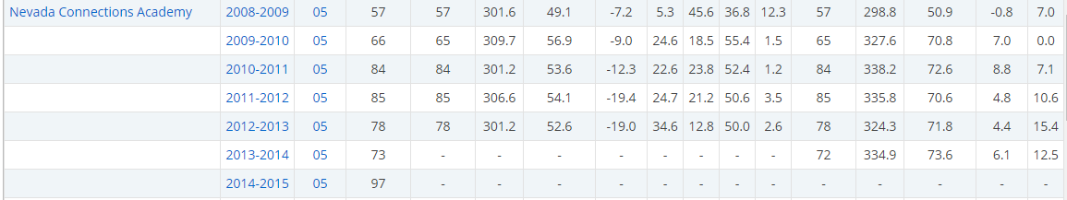

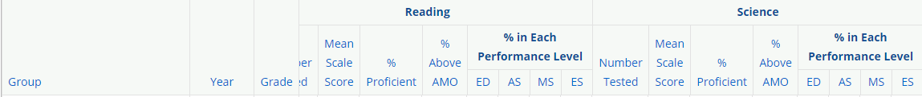
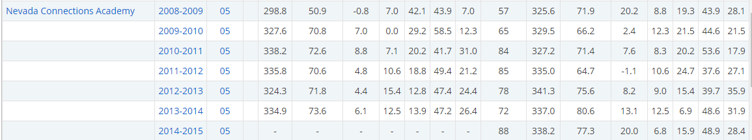

CRT (Old NV Standards), Grade 8
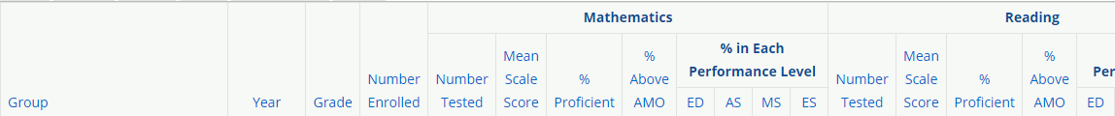
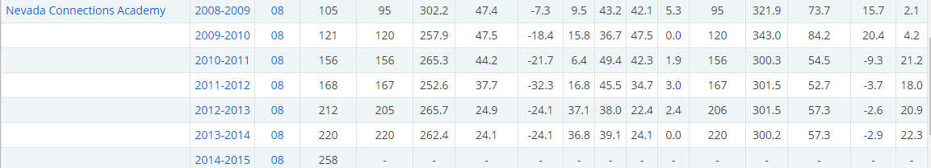
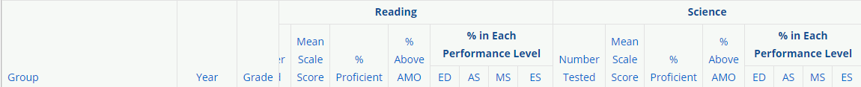
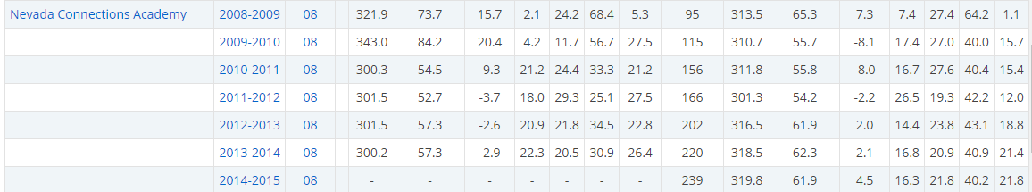
CRT (New NV Standards), Year 2015-2016, Grade 3
http://nevadareportcard.com/di/report/summary_1?report=summary_1&scope=e24.g3.y13&organization=c12305&scores=MA_AMO%2CRD_AMO%2CMA_level%2CRD_level%2CMA_pass%2CRD_pass%2CMA_SS%2CRD_SS%2CN_MA%2CN_RD&num=20&page=1&pagesize=20&domain=assessment&
CRT (New NV Standards), Year 2015-2016, Grade 4
http://nevadareportcard.com/di/report/summary_1?report=summary_1&scope=e24.g4.y13&organization=c12305&scores=MA_AMO%2CRD_AMO%2CMA_level%2CRD_level%2CMA_pass%2CRD_pass%2CMA_SS%2CRD_SS%2CN_MA%2CN_RD&num=20&page=1&pagesize=20&domain=assessment&
CRT (New NV Standards), Year 2015-2016, Grade 5
http://nevadareportcard.com/di/report/summary_1?report=summary_1&scope=e24.g5.y13&organization=c12305&scores=MA_AMO%2CRD_AMO%2CMA_level%2CRD_level%2CMA_pass%2CRD_pass%2CMA_SS%2CRD_SS%2CN_MA%2CN_RD&num=20&page=1&pagesize=20&domain=assessment&
CRT (New NV Standards), Year 2015-2016, Grade 8 (includes Science)

ACT, Year 2015-2016, Grade 11 State Public Schools
http://nevadareportcard.com/di/report/summary_1?report=summary_1&scope=e25.g11.y13&organization=c12305&scores=AC_SS%2CN_MA%2CN_EN%2CN_RD%2CN_SC%2CN_WR%2CMA_SS%2CEN_SS%2CRD_SS%2CSC_SS%2CWR_SS&num=20&page=1&pagesize=20&domain=assessment&

Graduation Rates
Accountability Year | Class of | Total | Graduation Rate
2006-2007 | 2007 | - | -
2007-2008 | 2008 | - | -
2008-2009 | 2009 | 12 | blank
2009-2010 | 2010 | 25 | 36.4
2010-2011 | 2011 | 325 | 26.5
2011-2012 | 2012 | 383 | 36.08
2012-2013 | 2013 | 491 | 33.91
2013-2014 | 2014 | 468 | 37.19
2014-2015 | 2015 | 685 | 35.63
2015-2016 | 2016 | 914 | 40.09

Graduation Rates
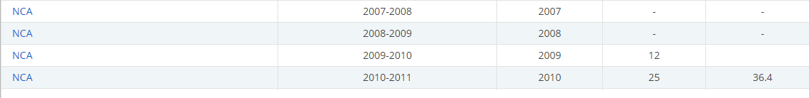
http://nevadareportcard.com/di/report/reportcard_1?report=reportcard_1&scope=e22.y1.y2.y3.y4.y5.y6.y8.y9&organization=c12305&fields=309%2C310%2C311%2C313%2C318%2C320&hiddenfieldsid=309%2C310%2C311%2C313%2C318%2C320&scores=690%2C700&num=160&page=2&pagesize=20&domain=leaver&
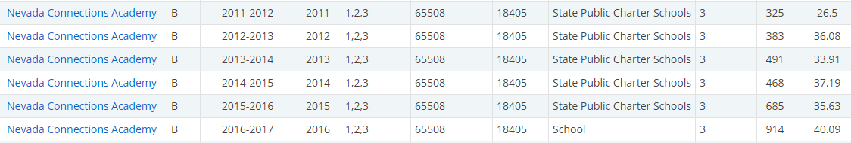
http://nevadareportcard.com/di/report/reportcard_1?report=reportcard_1&scope=e20.y10.y11.y12.y13.y14.y7&organization=c12305&fields=309%2C310%2C311%2C313%2C318%2C320&scores=1007%2C1015&num=160&page=2&pagesize=20&domain=cohort&

Information:
 | General Information about the corporation running Connections For-Profit Corporations | http://www.sourcewatch.org/index.php/Connections_Academy
2012 | Class Action – Lists multiple concerns | http://www.sourcewatch.org/images/e/ed/K12_Amended_Class_Action_Complaint.pdf
2013 | Nevada students in charter schools shortchanged on learning time, study shows | https://lasvegassun.com/news/2013/jun/25/nevada-students-charter-schools-falling-behind-stu/
2013 | Jeb Bush Promotes | http://fox43.com/2013/01/31/jeb-bush-give-students-the-choice-of-digital-schools/
2015 | Questionable operation in California | http://www.ncpolicywatch.com/2015/03/04/k12-inc-backer-of-future-nc-virtual-charter-school-runs-questionable-operation-in-california/
Jan 2016 | Nevada Connections Response to Regulations | http://charterschools.nv.gov/uploadedFiles/CharterSchoolsnvgov/content/News/2016-01-22%20NCA%20Comments%20on%20Proposed%20Regulations.pdf
May 2016 | Graduation Improvement Plan | http://charterschools.nv.gov/uploadedFiles/CharterSchoolsnvgov/content/News/Nevada%20Connections%20Academy%20-%20Graduation%20Rate%20Improvement%20Plan%20-%20FINAL.pdf
2016 | Revoke Charter Contract | https://drive.google.com/file/d/0B7bJdQH4mFmEU0I3RTRXVFBzUGM/view
2016 | Facing Closure | http://www.fox5vegas.com/story/31569552/the-authority-held-a-public-meeting-to-discuss-the-status-of-four-online-charter-schools
2016 | Shutting Down | http://www.ktnv.com/news/four-state-online-schools-at-risk-of-shutting-down
2016 | Nevada Connections Academy Notice of Intent to Revoke Responses | http://charterschools.nv.gov/uploadedFiles/CharterSchoolsnvgov/content/News/NCA%20Response%20to%20Revocation.pdf
Sept 2016 | Pursuant to NRS 388A.330 and NAC 386.330, the Authority direct staff to Issue a Notice of Intent to Revoke the Written Charter of Nevada Connections Academy based on having a graduation rate for the preceding school year that is less than 60 percent. | http://charterschools.nv.gov/uploadedFiles/CharterSchoolsnvgov/content/News/160923%20Board%20Agenda%20Item%204Nevada%20Connections%20Academy%20Update.pdf
Sept 2016 | Noted fiscal mismanagement | http://charterschools.nv.gov/uploadedFiles/CharterSchoolsnvgov/content/News/92316%20charter%20contin.pdf
Oct 2016 | Nevada Connections Academy in danger of closing | http://www.ktnv.com/news/nevada-connections-academy-in-danger-of-closing
Dec 2016 | Hearing for Nevada Connections Academy postponed | http://www.reviewjournal.com/news/education/hearing-nevada-connections-academy-postponed
Feb 2017 | Low graduation rates | https://thenevadaindependent.com/article/charter-schools-notice-state-board-low-graduation-rates

Charter Authority Mentions
October 21, 2016 Minutes
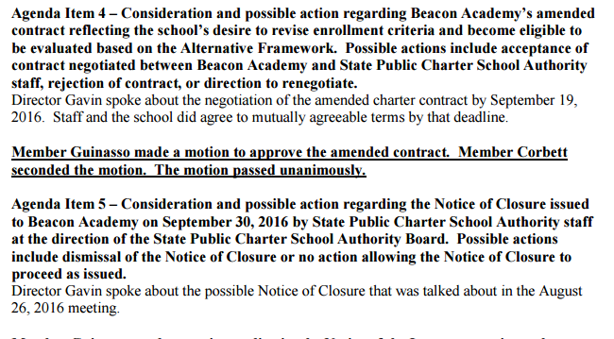
http://charterschools.nv.gov/uploadedFiles/CharterSchoolsnvgov/content/News/October%2021,%202016-DRAFT%20SPCSA-Board-Minutes.pdf
Dec 16, 2016 Agenda
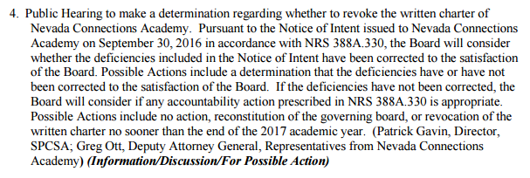
http://charterschools.nv.gov/uploadedFiles/CharterSchoolsnvgov/content/News/December-16-2016-FINALSPCSA-Board-Meeting-Agenda.pdf
September 23, 2016 Agenda
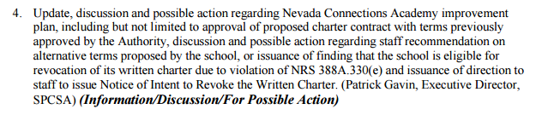
http://charterschools.nv.gov/uploadedFiles/CharterSchoolsnvgov/content/News/September-23-2016-FINALSPCSA-Board-Meeting-Agenda-change.pdf
September 23, 2016 Minutes
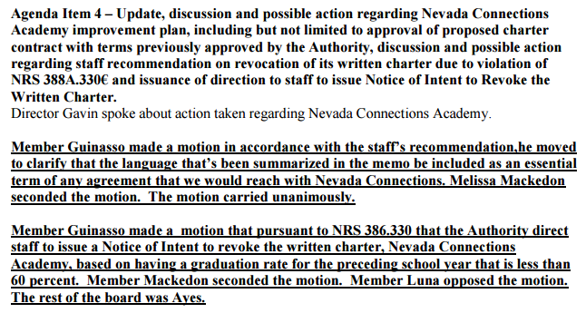
http://charterschools.nv.gov/uploadedFiles/CharterSchoolsnvgov/content/News/September%2023%202016-DRAFT%20SPCSA-Board-Minutes.pdf
August 26, 2016 Agenda
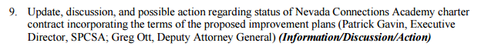
http://charterschools.nv.gov/uploadedFiles/CharterSchoolsnvgov/content/News/August-26-2016-DRAFT-SPCSA-Board-Meeting-Agenda-change.pdf
August 26, 2016 Minutes
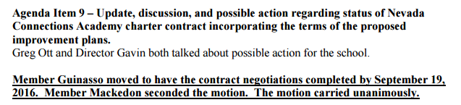
http://charterschools.nv.gov/uploadedFiles/CharterSchoolsnvgov/content/News/Augusgt%2026,%202016-FINALSPCSA-Board-Minutes.pdf
July 29, 2016 Agenda
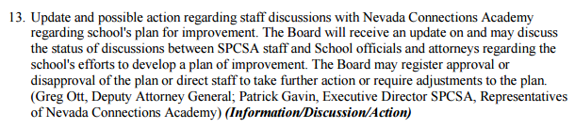
http://charterschools.nv.gov/uploadedFiles/CharterSchoolsnvgov/content/News/July-29-2016-FINAL-SPCSA-Board-Meeting-Agenda.pdf

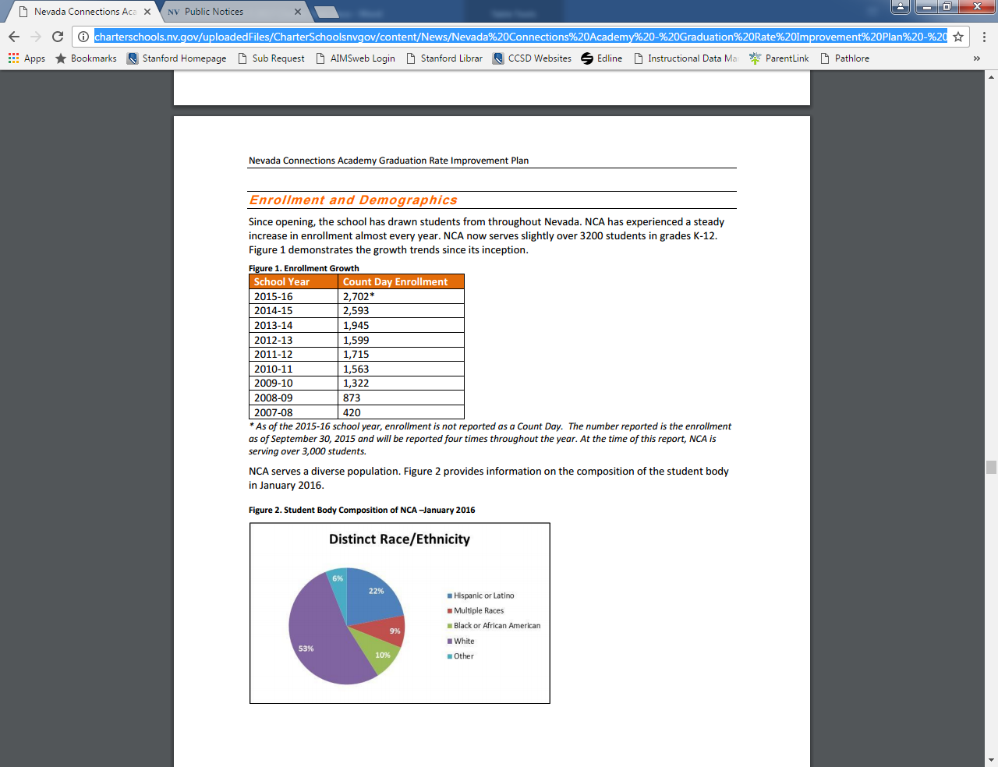
http://charterschools.nv.gov/uploadedFiles/CharterSchoolsnvgov/content/News/Nevada%20Connections%20Academy%20-%20Graduation%20Rate%20Improvement%20Plan%20-%20FINAL.pdf

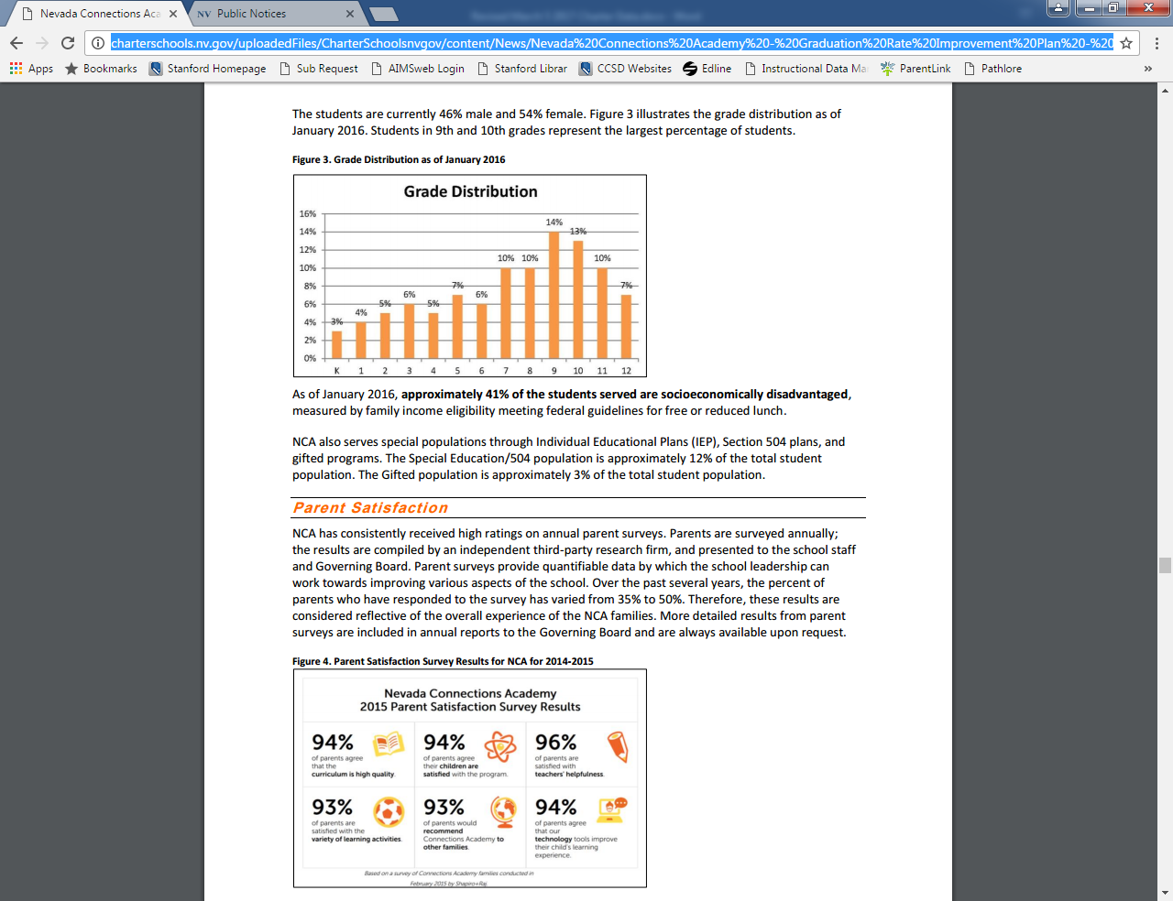
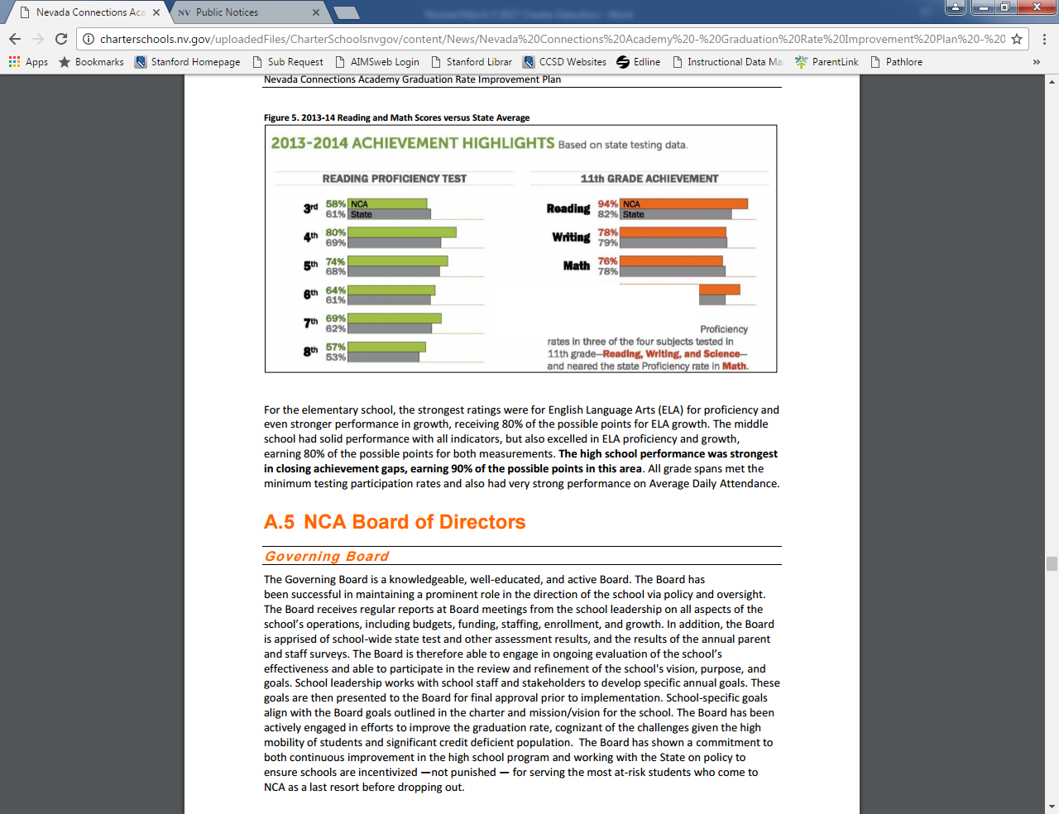
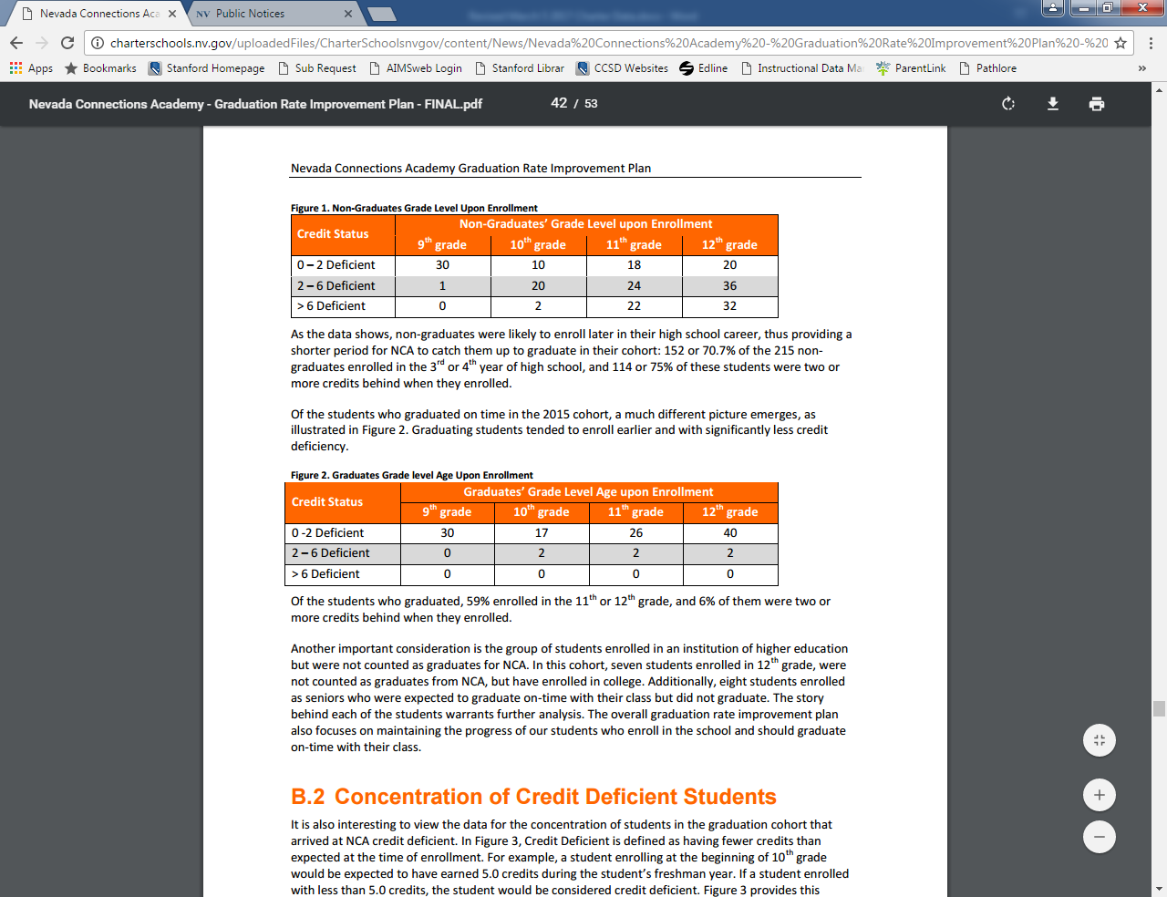
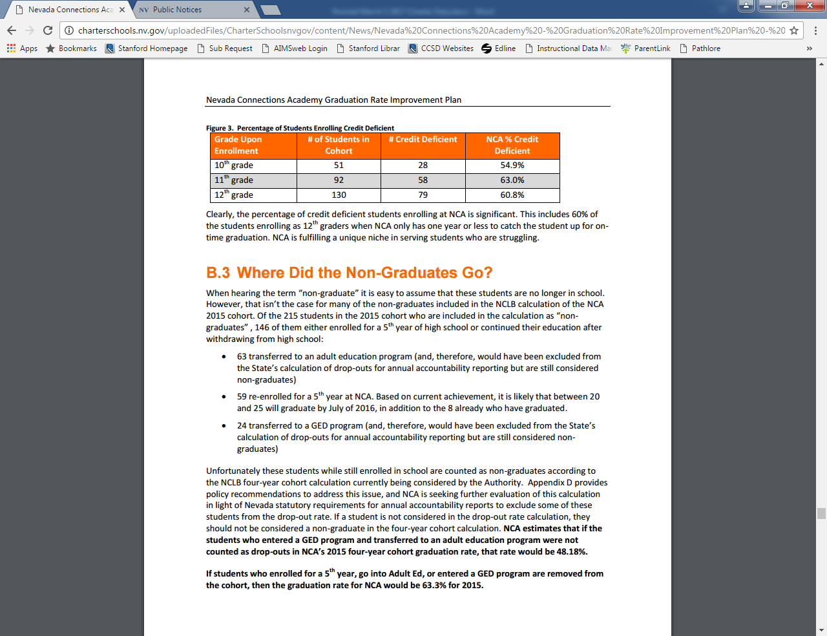
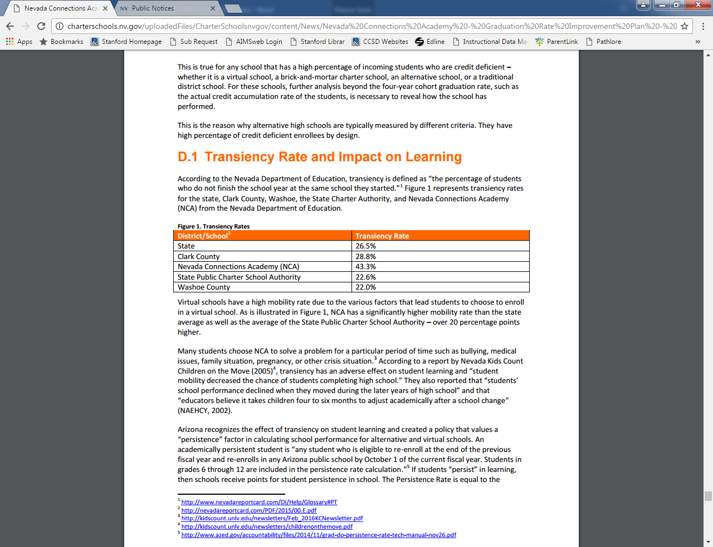
http://charterschools.nv.gov/uploadedFiles/CharterSchoolsnvgov/content/News/Nevada%20Connections%20Academy%20-%20Graduation%20Rate%20Improvement%20Plan%20-%20FINAL.pdf

